1. Merge Two Sorted Lists

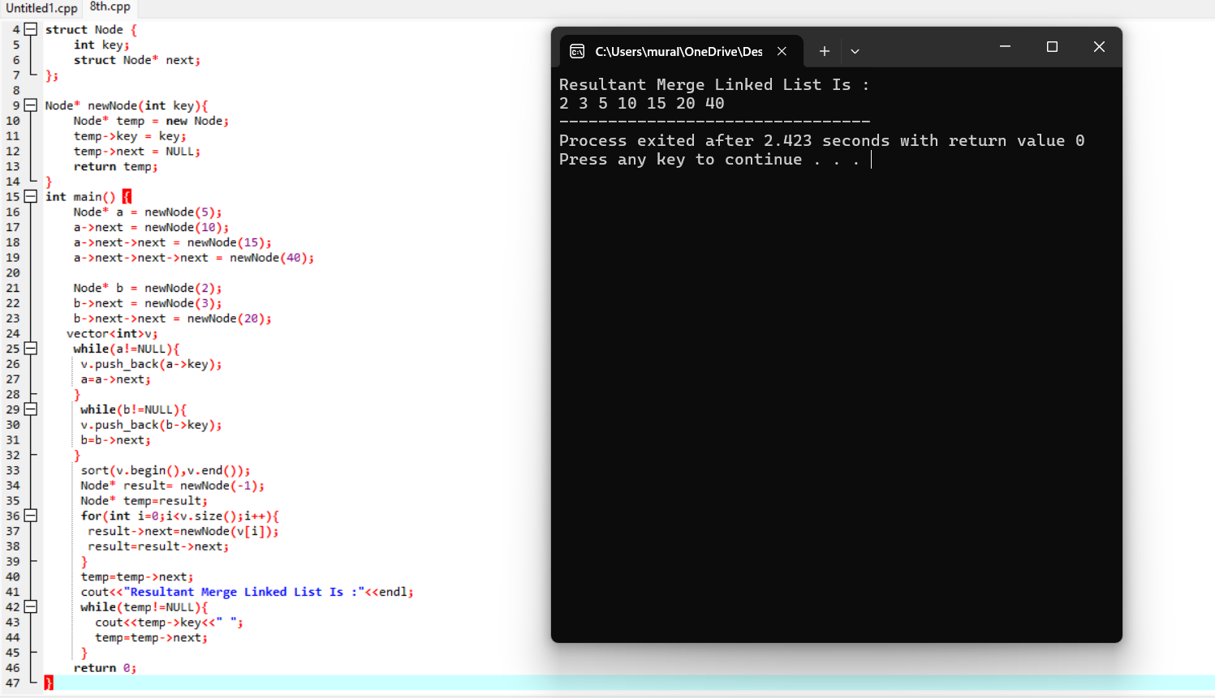

1. Merge k Sorted Lists

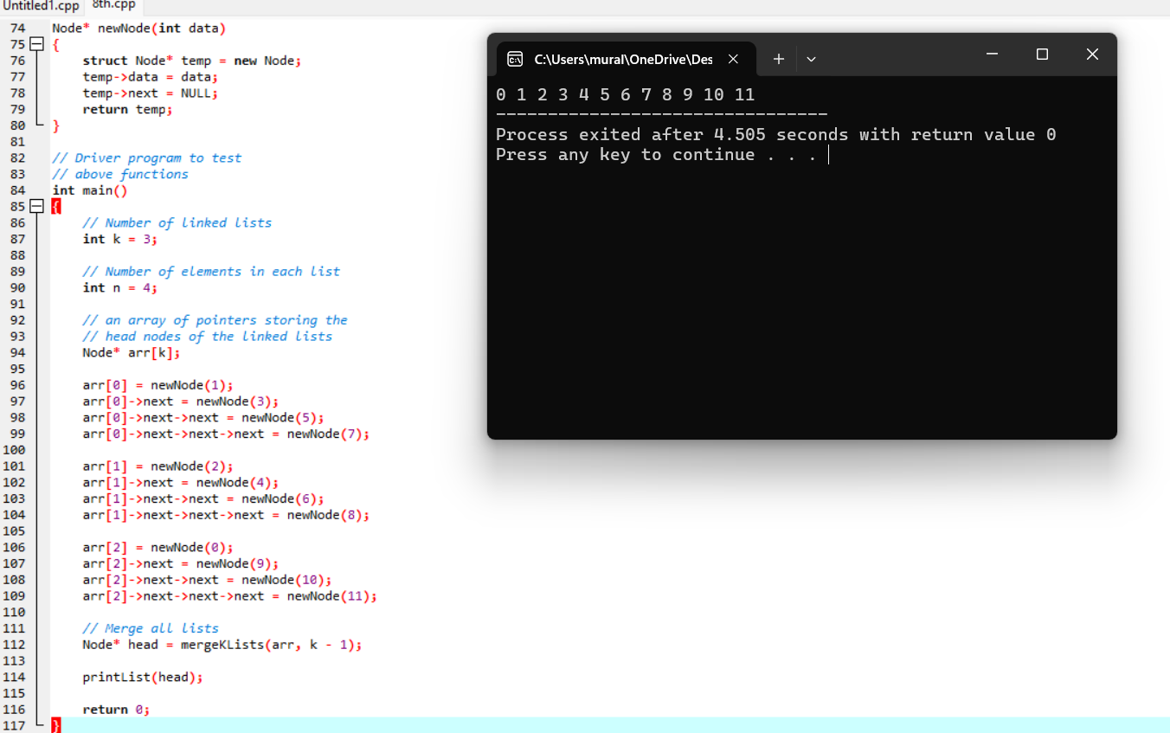

1. Remove Duplicates from Sorted Array

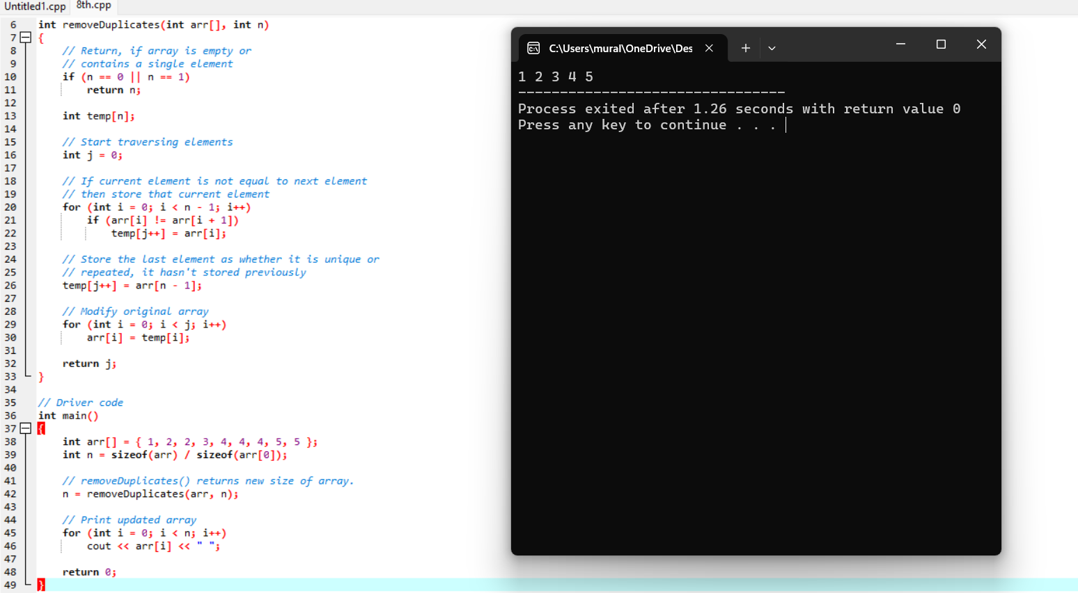

1. Search in Rotated Sorted Array

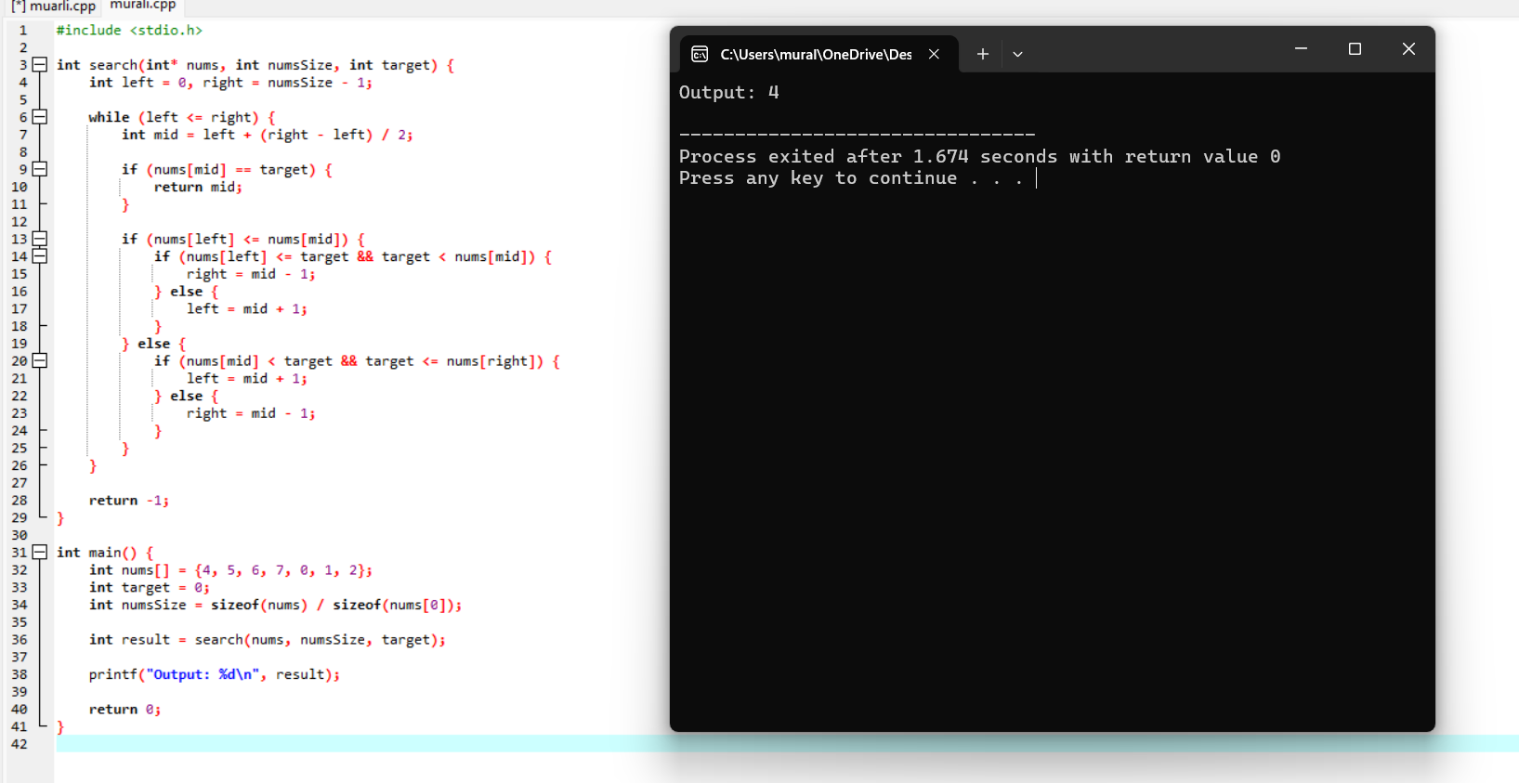

1. Find First and Last Position of Element in Sorted Array

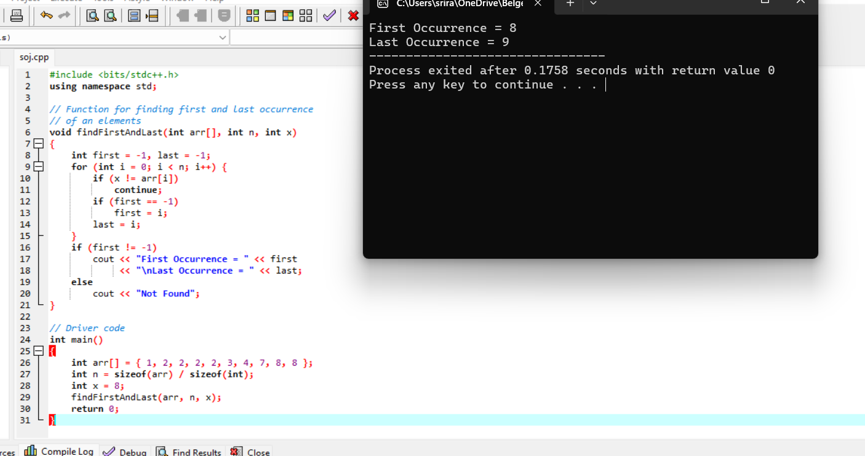

1. Sort Colors

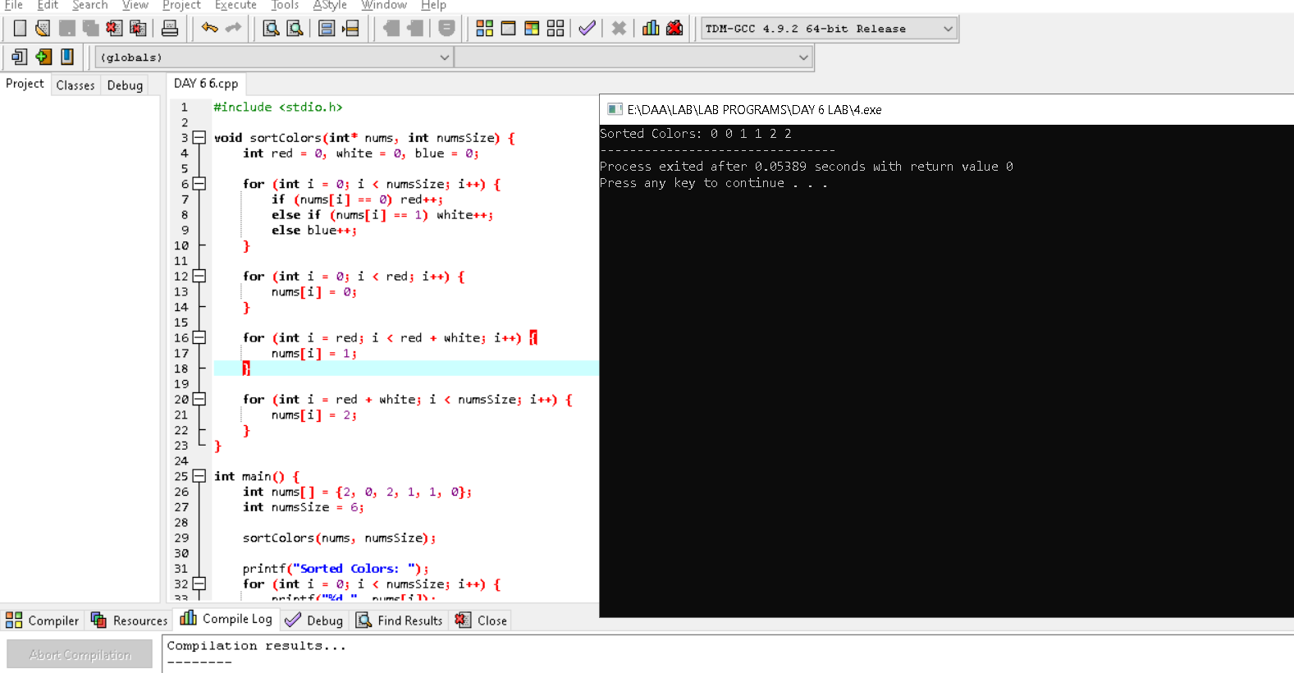

1. Remove Duplicates from Sorted List

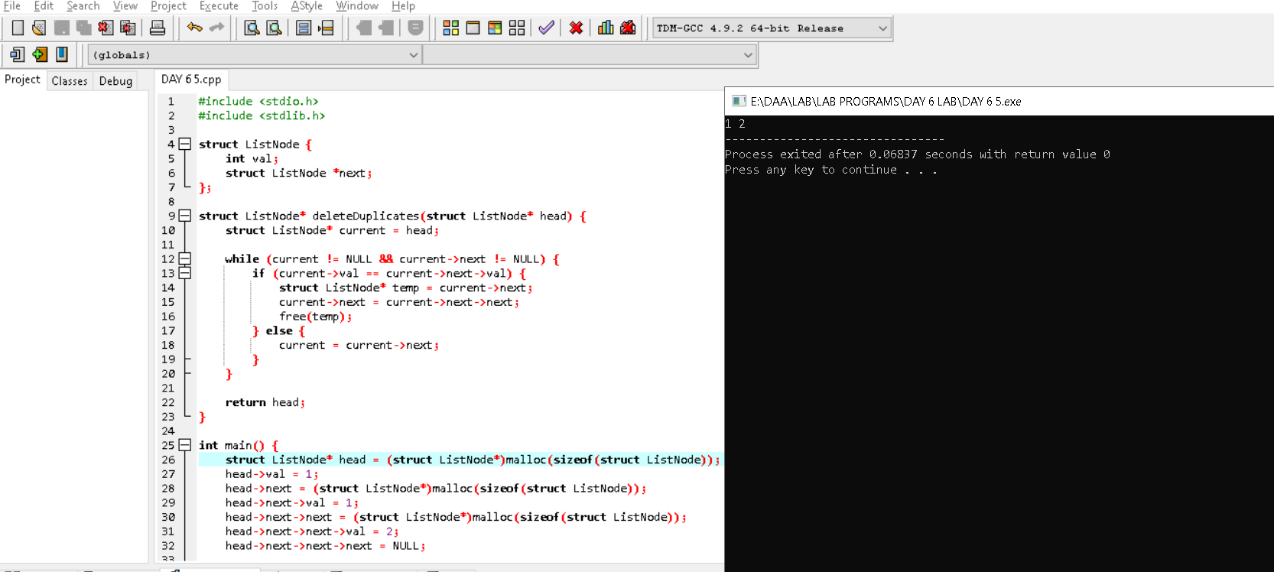

1. Merge Sorted Array

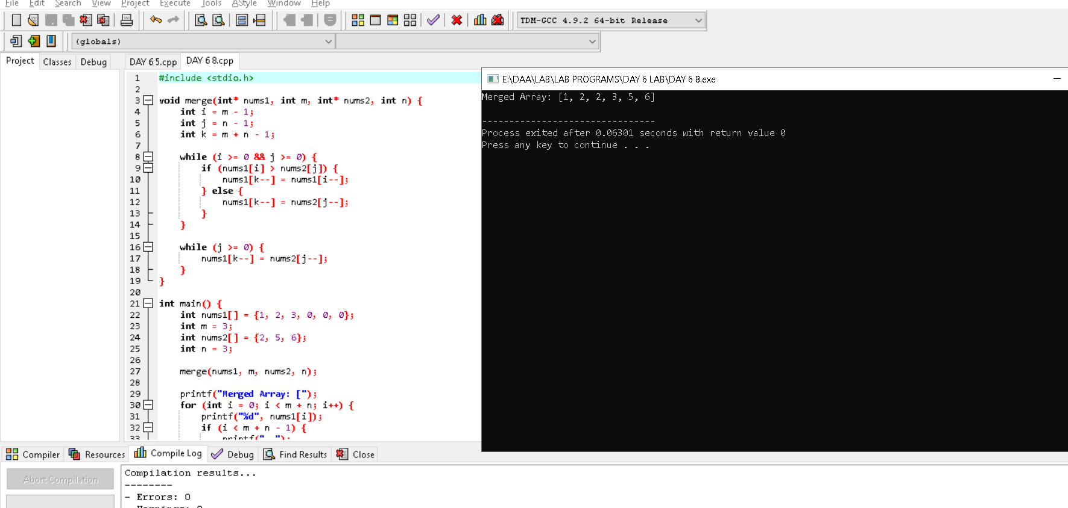

1. Convert Sorted Array to Binary Search Tree

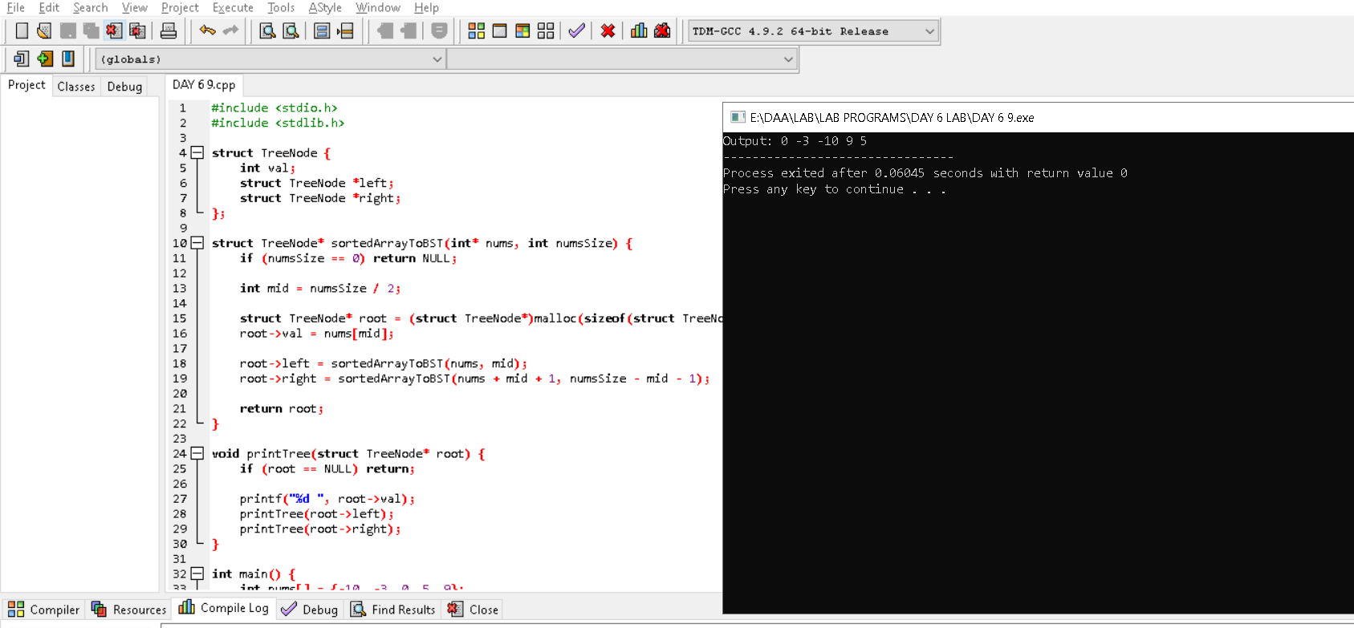

1. Convert Sorted Array to Binary Search Tree

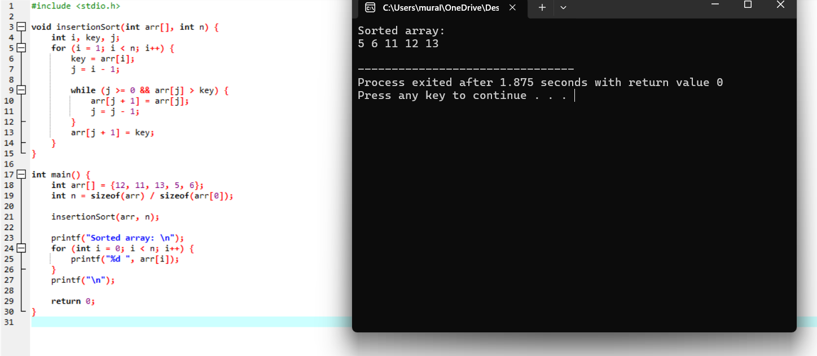

1. Sort Characters By Frequency

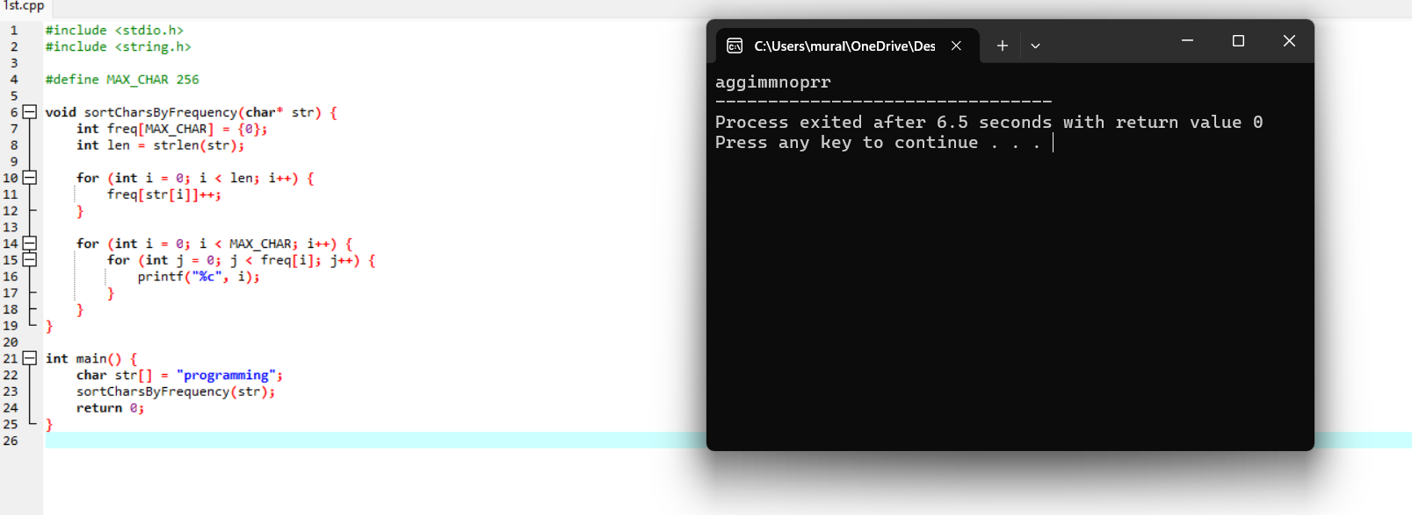

1. Max Chunks To Make Sorted

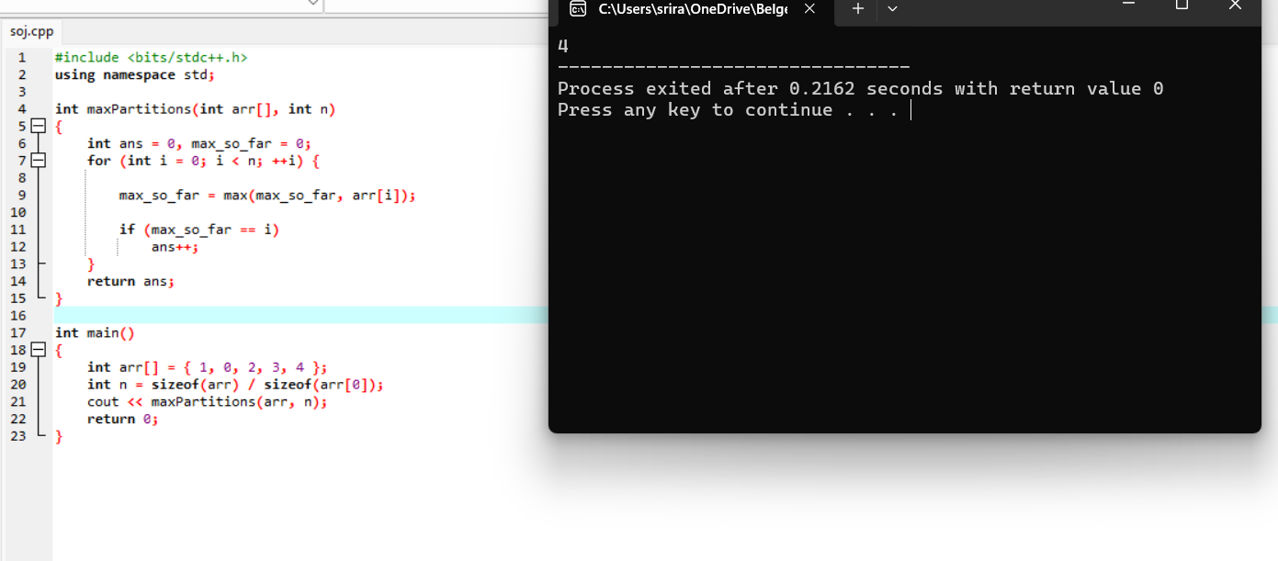

1. Intersection of Three Sorted Arrays

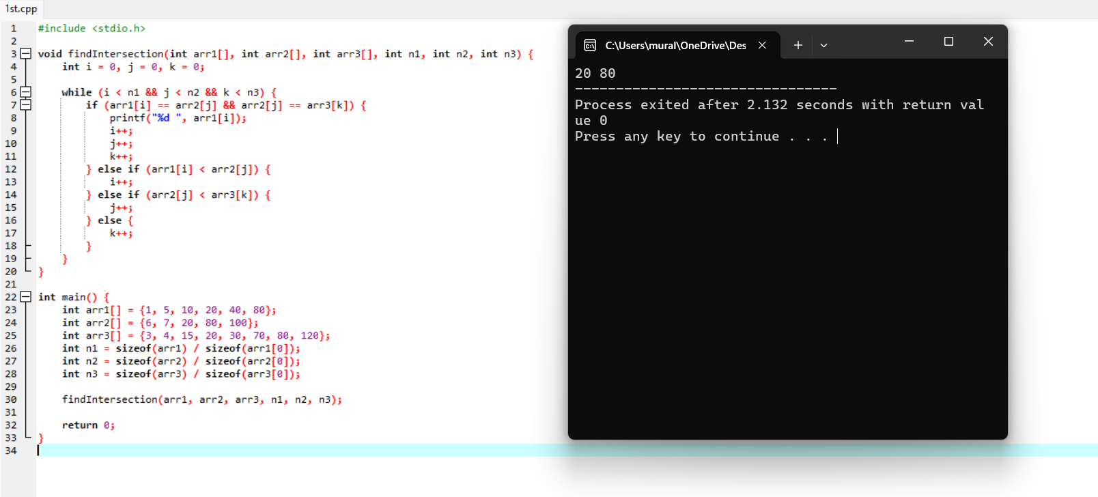

1. Sort the Matrix Diagonally

